***LAB-06: Informed search algorithms***

***Objectives:***

* Implementation of an inform search algorithm (A-star)

***Lab Outcomes:***

Students should get familiar with:

* How A* uses heuristics to reach a goal
* How to write a program in python to solve a maze problem

***Lab Requirements:***

* Jupyter notebook (Anaconda 3)

***A-star search algorithm:***

Some common terminologies in A-star search algorithm:

* **Node** (also called **State**) — All potential position or stops with a unique identification.
* **Transition** — The act of moving between states or nodes.
* **Starting Node —**Where to start searching
* **Goal Node —**The target to stop searching.
* **Search Space** — A collection of nodes, like all board positions of a board game
* **Cost**— Numerical value (say distance, time, or financial expense) for the path from a node to another node.
* **g(n)** — this represents the **exact cost** of the path from the **starting node** to any node **n**
* **h(n)** — this represents the heuristic **estimated cost** from node **n** to the goal node.
* **f(n)**— lowest cost in the neighboring node n

***Each time A* enters a node, it calculates the cost***

f(n) = g(n) + h(n)

***Solving a maze problem with python:***

***A brief description of the problem:***

Here you will solve a maze problem. You have to find the shortest path in the maze from a start node to the end node.

#### *The problem’s description*

For this problem, there are four moves (left, right, up, and down) from a maze position provided a valid step is available. In red square positions, no movement is allowed (like in start position only down motion is available since up and left move are blocked by the wall while for the right is a red square position thus no movement allowed).

First, we will create a class for a node that will contain all the attributes associated with the node like the parent of the node, position of the node, and all three costs (g,h & f) for the node. We initialize the node and build a method for checking the equality of the node with another node.

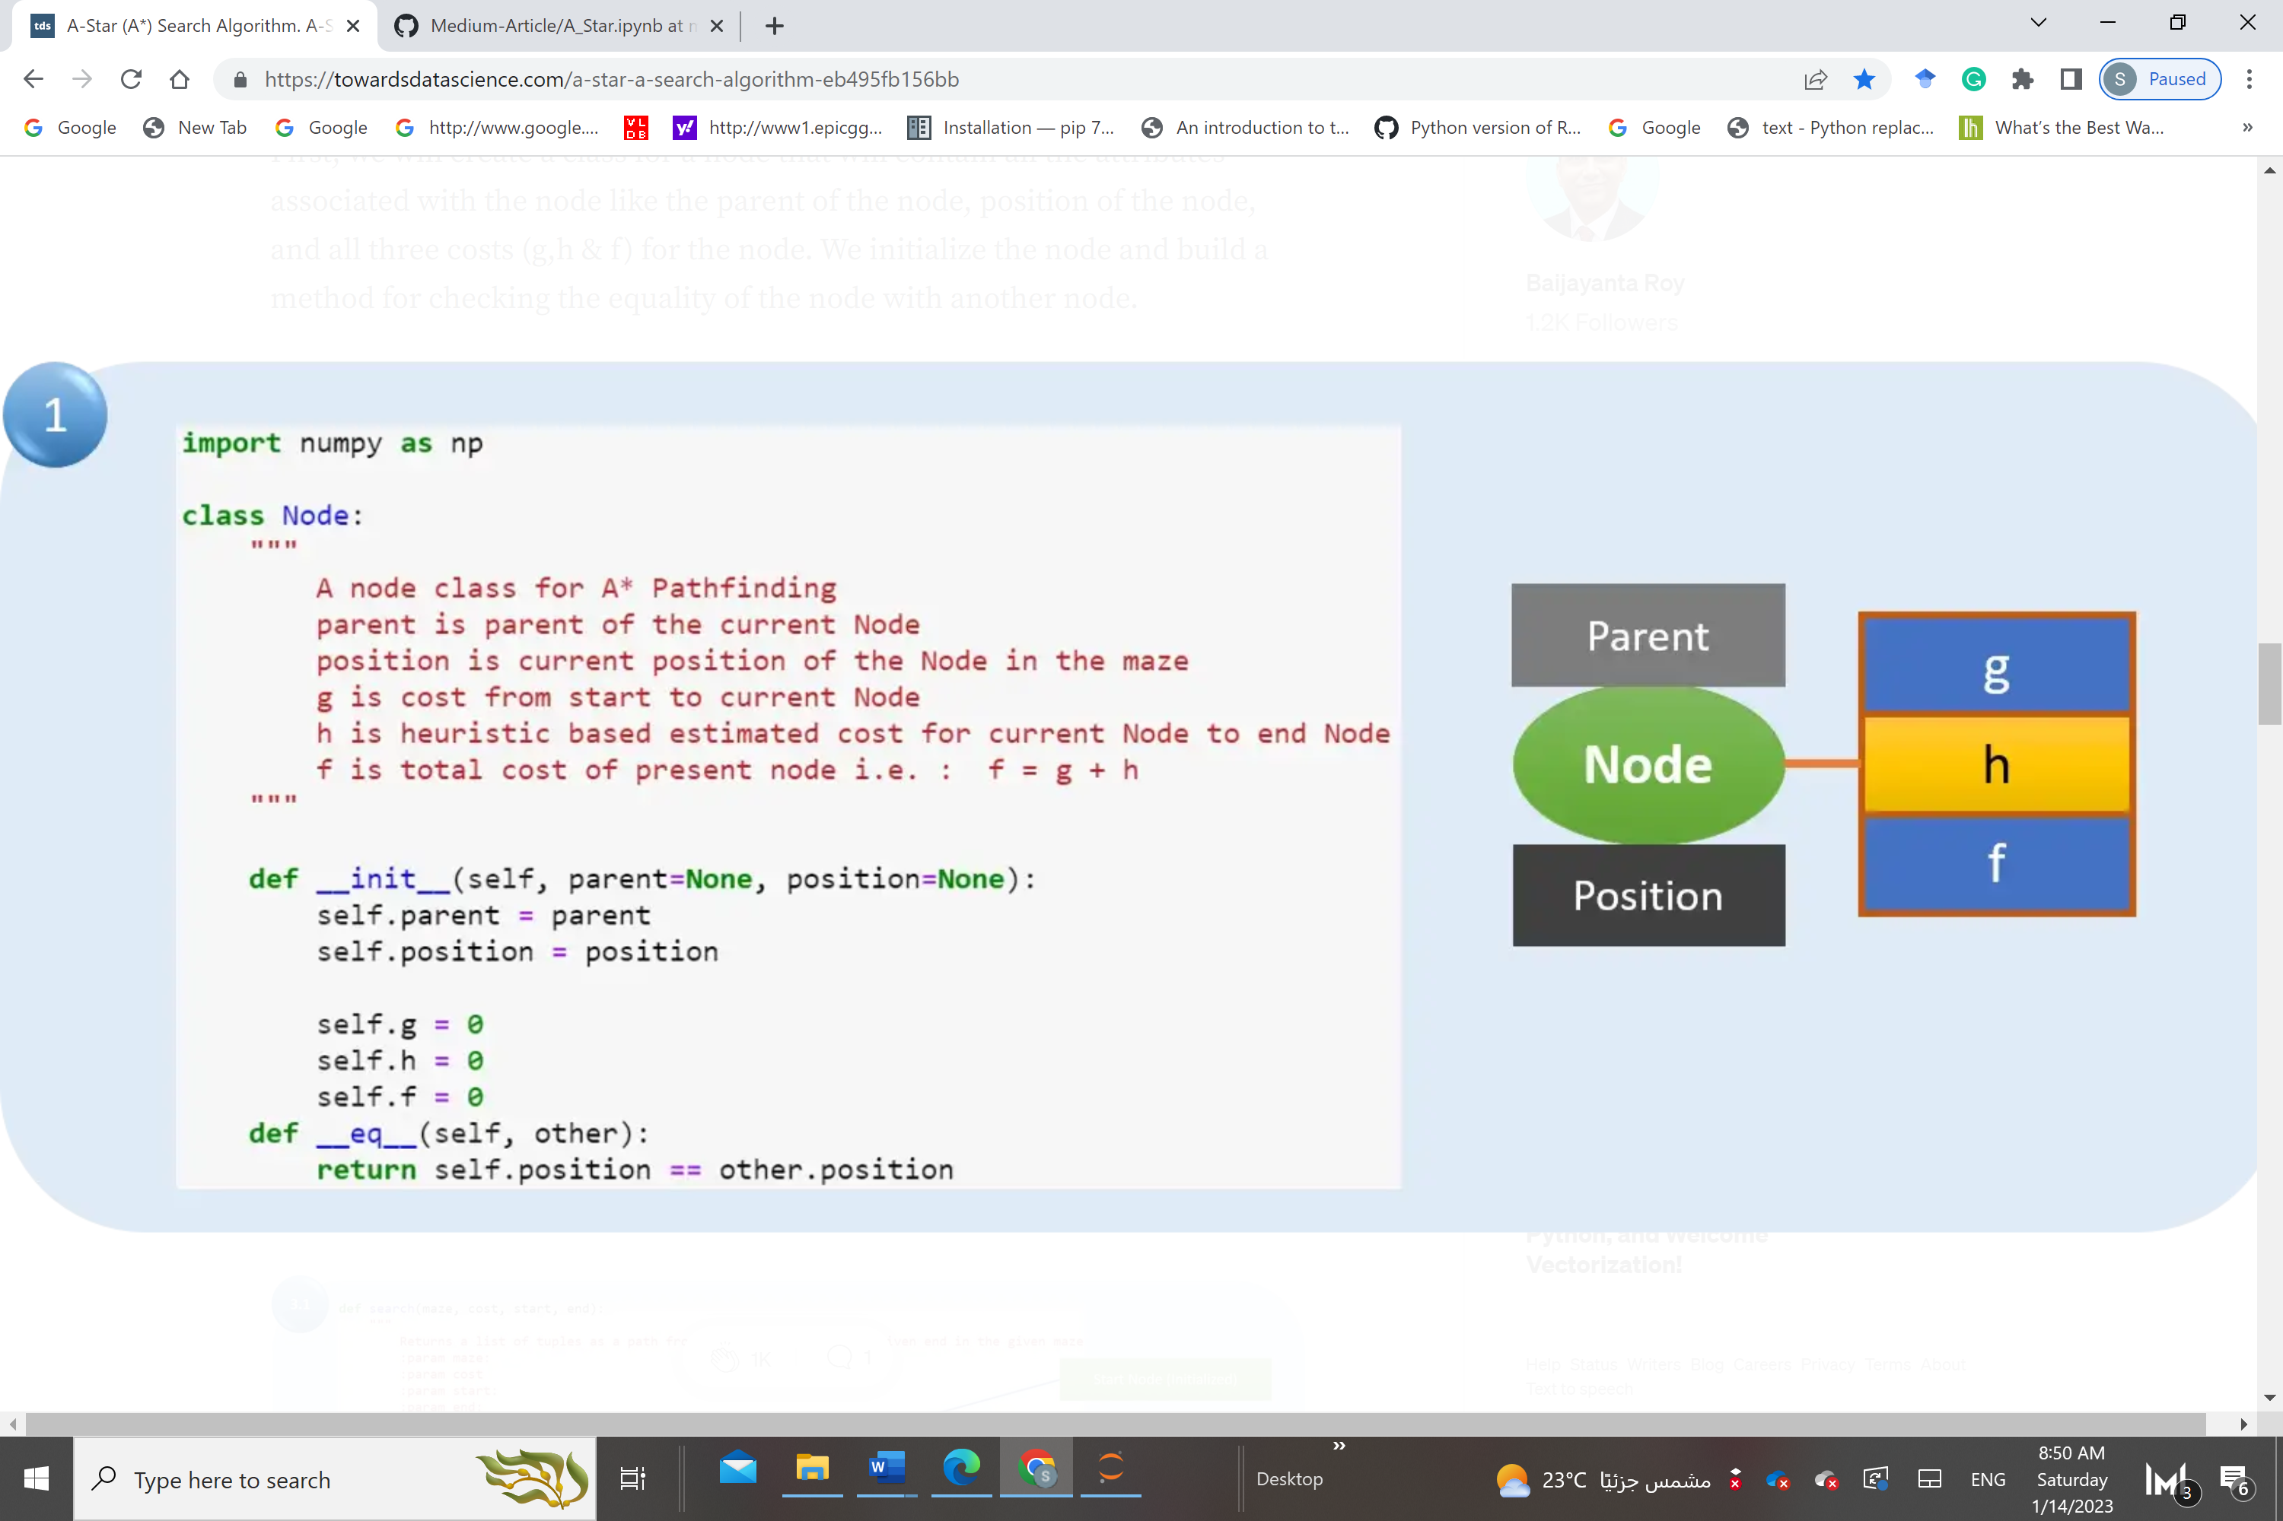

Now we will build the path function, which will be used to return the path from the start node to the target node (end node).

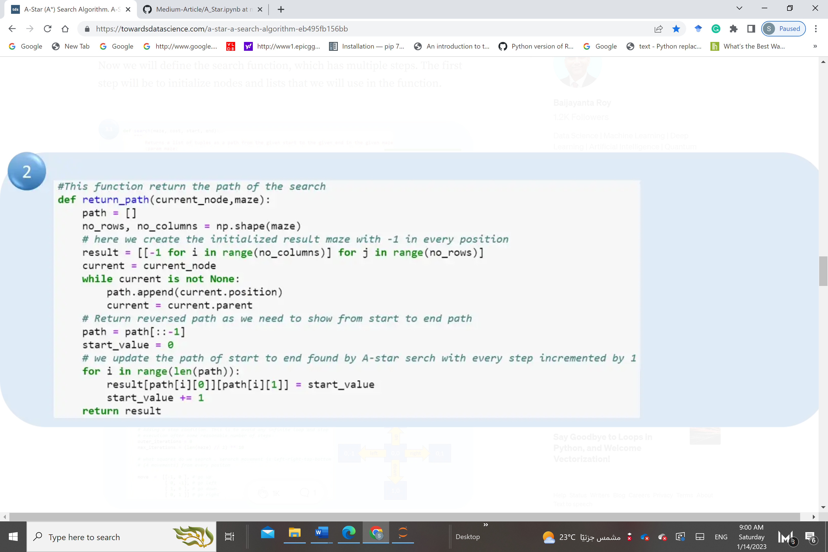

Now we will define the search function, which has multiple steps. The first step will be to initialize nodes and lists that we will use in the function.

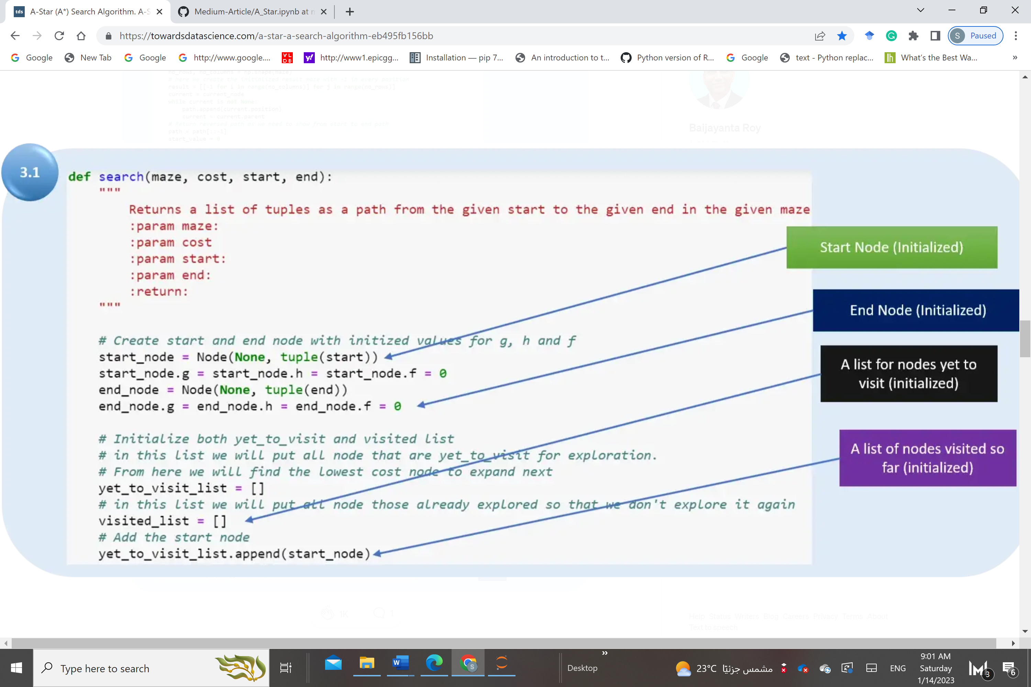

Add the starting node to the “yet to visit list.” Define a stop condition to avoid an infinite loop. Define movement in terms of relative position, which will be used to find the child node and other relative positions.

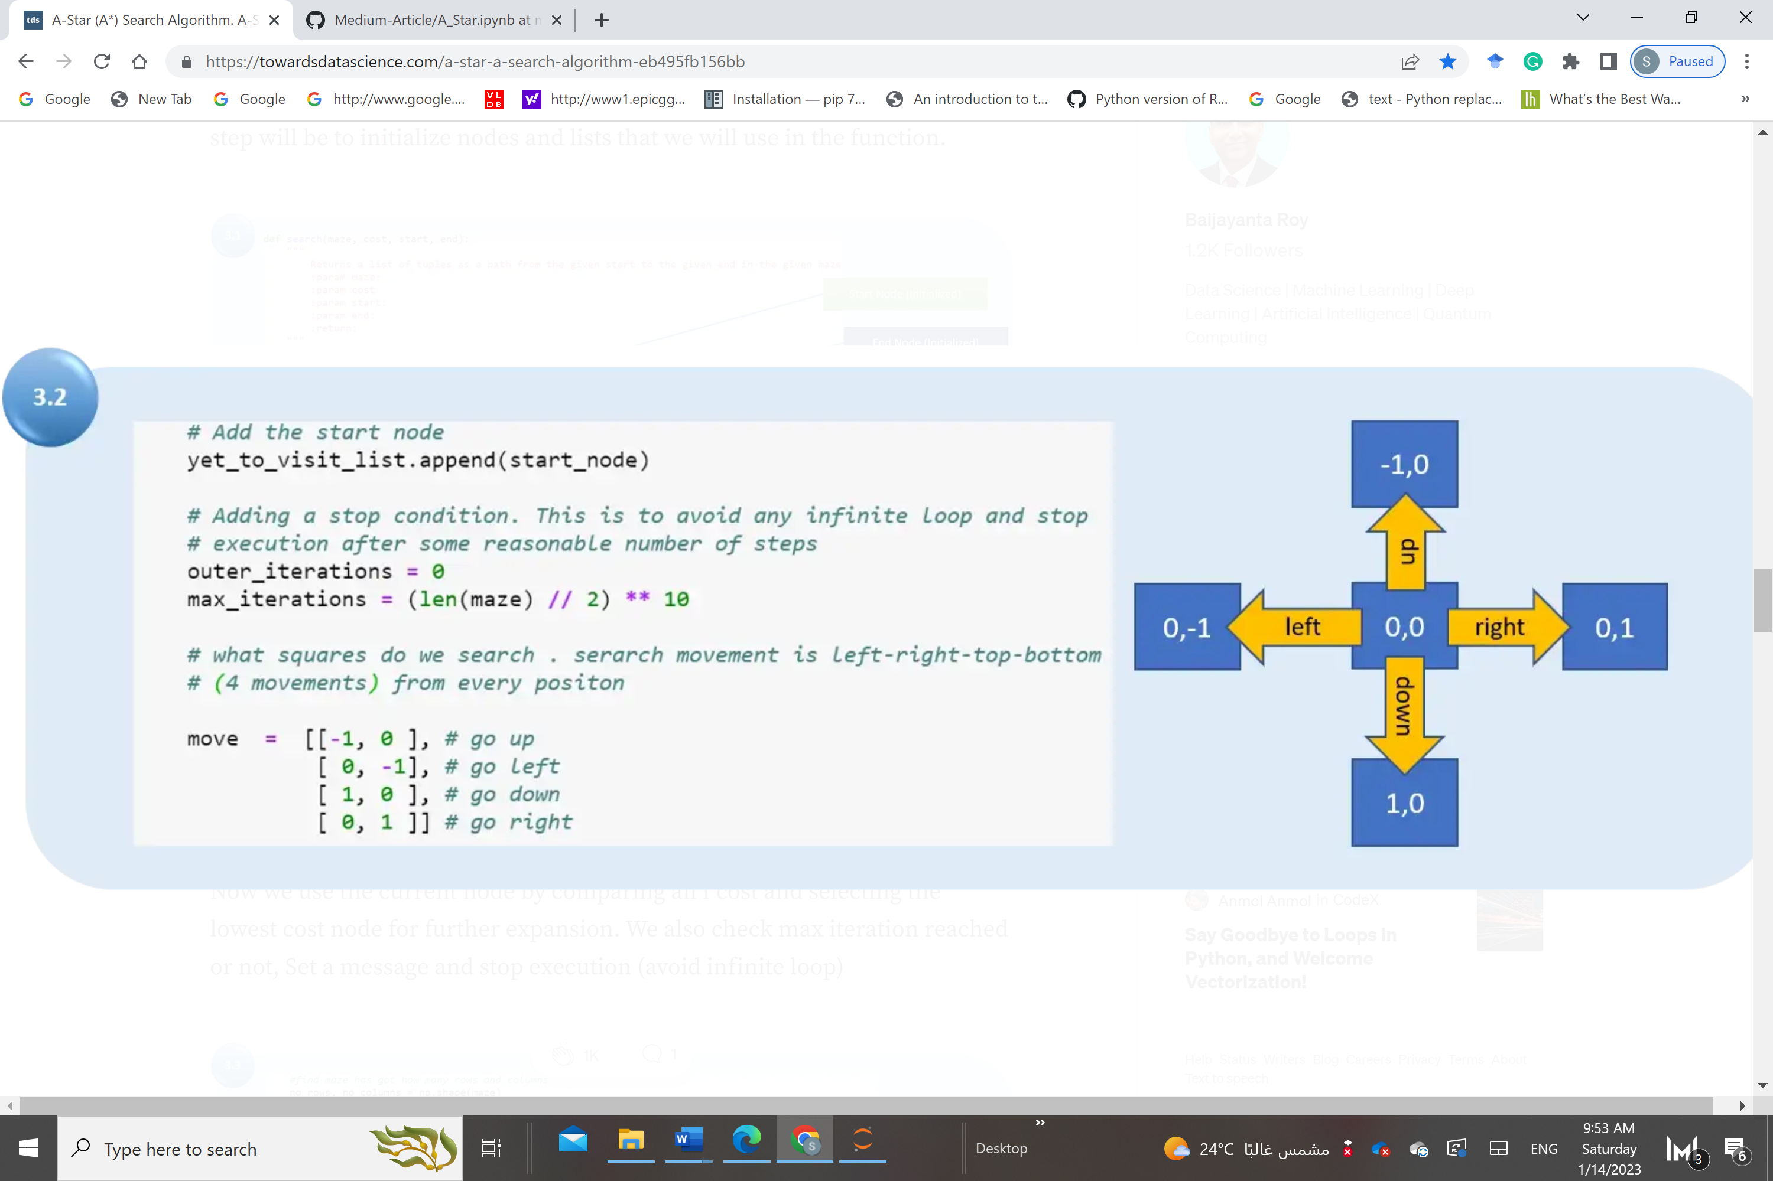

Now we use the current node by comparing all f cost and selecting the lowest cost node for further expansion. We also check max iteration reached or not, Set a message and stop execution (avoid infinite loop)

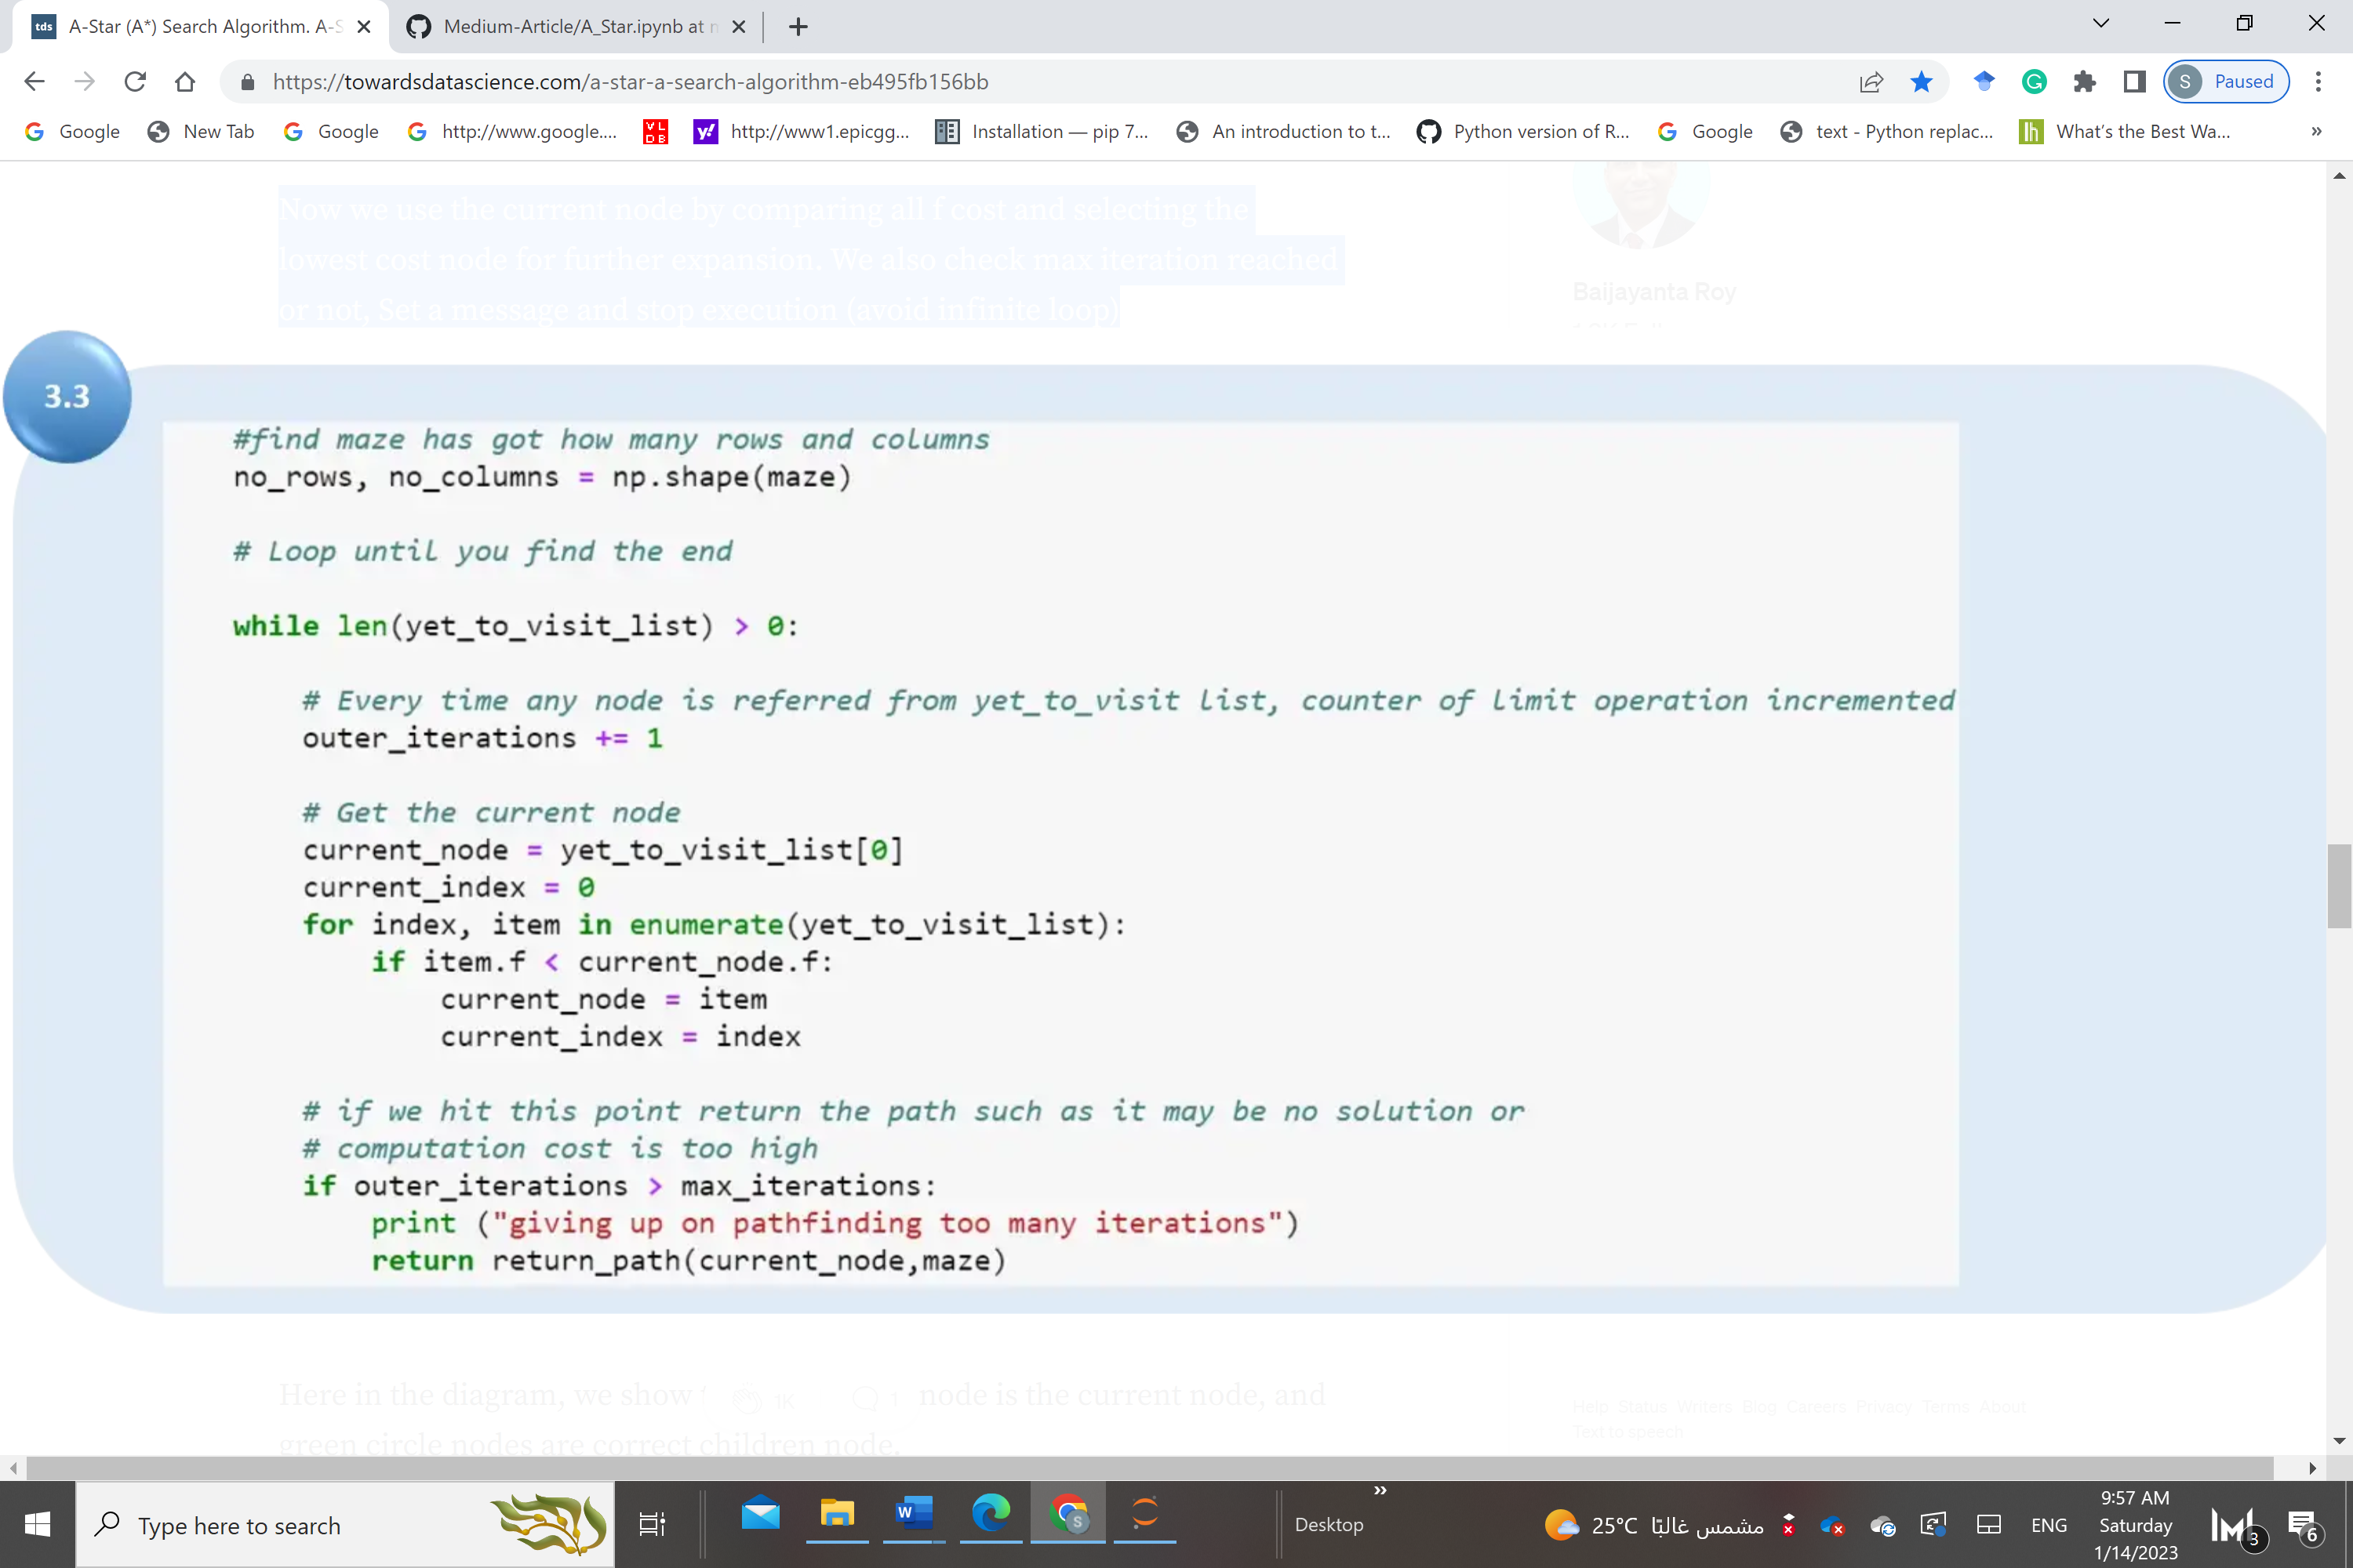

Remove the selected node from “yet to visit list” and add this node to the visited list. Now we put a check if we found the target square. If we have located the target square, then call the path function and return.

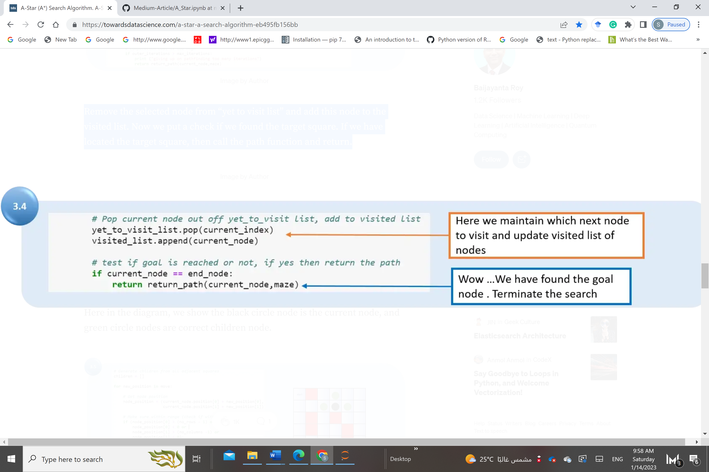

For the selected node, find out all children (use the move to find children). Get the current position for the selected node (this becomes the parent node for the children)  
a) check if a valid location exists (boundary wall will make few nodes invalid)  
b) if any node position is invalid (red square) then ignore that  
c) add to valid children node list for the selected parent

Here in the diagram, we show the black circle node is the current node, and green circle nodes are correct children node.

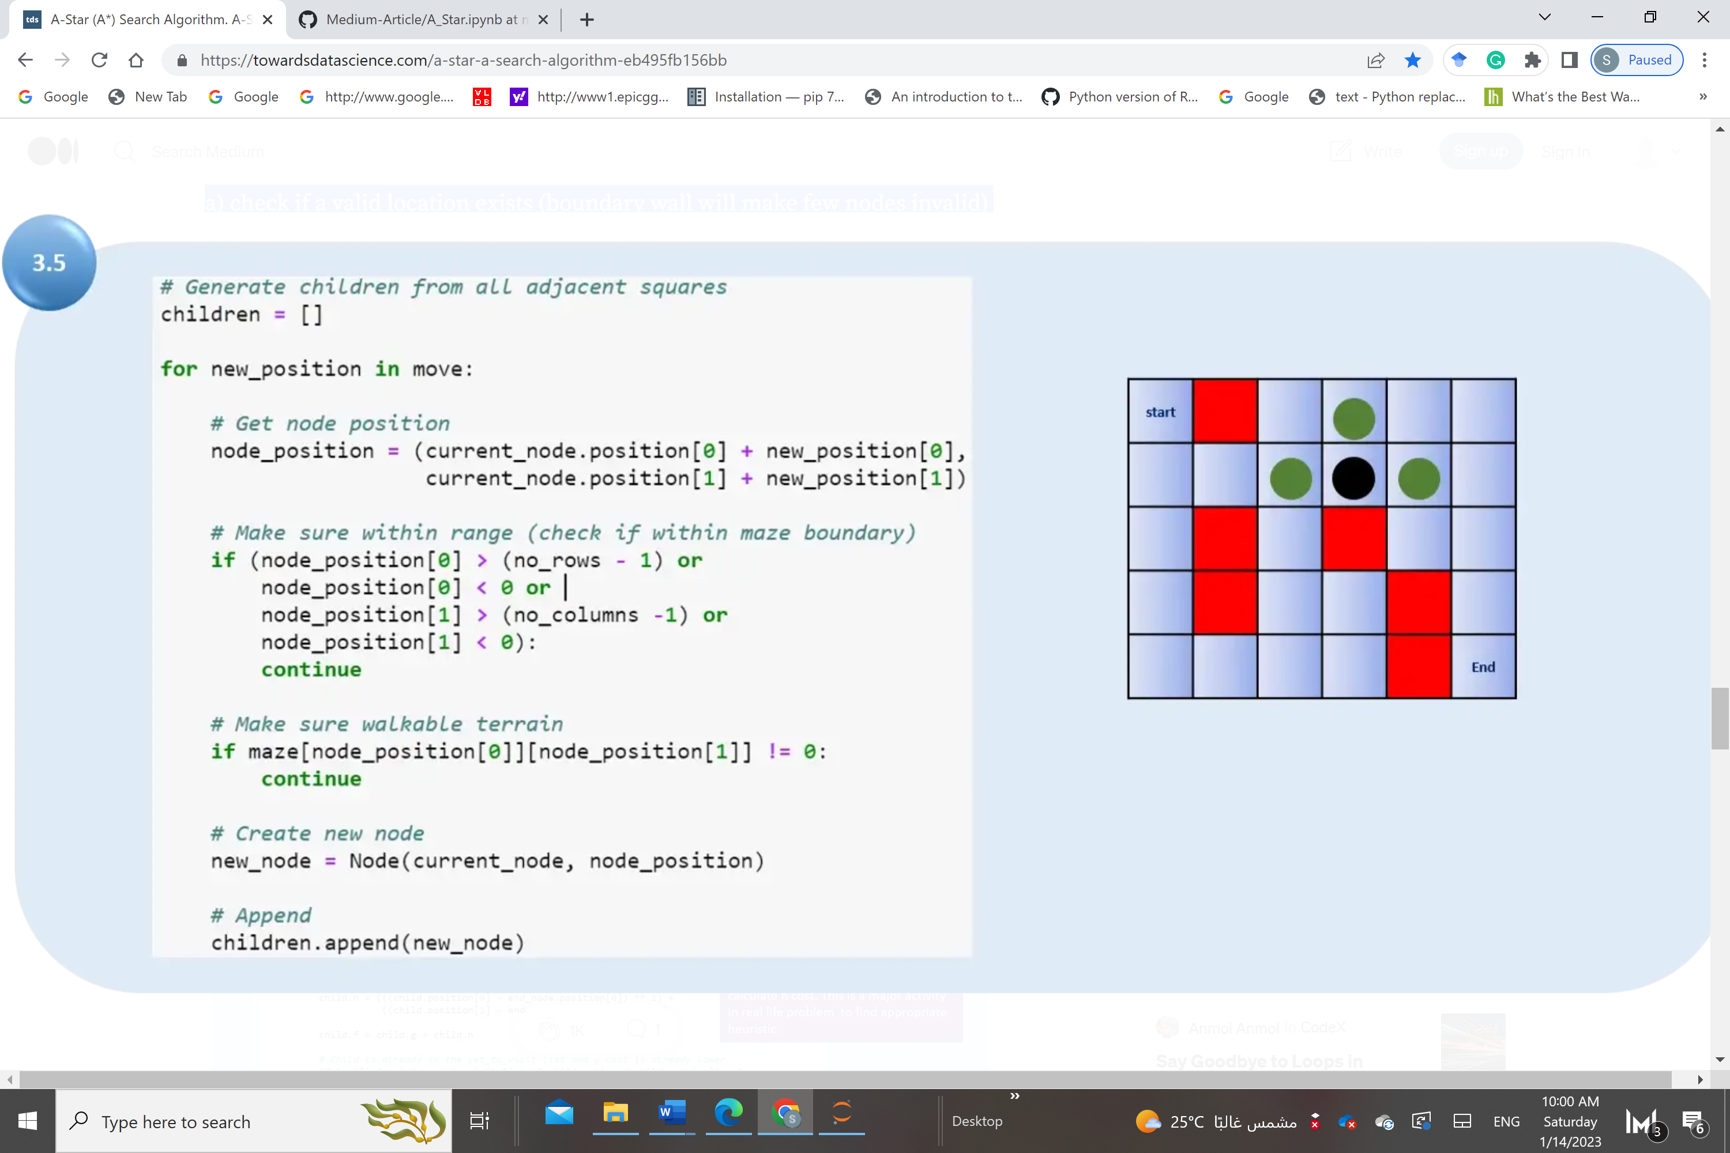

For all child node:  
a) if the child is in the visited list, then ignore it and try the next child node.  
b) calculate child node g, h, and f values. For h heuristic for the cost to reach the goal node for the current node is calculated here using euclidean distance.  
c) if the child in “yet to visit list” then ignore it else, move the child to “yet to visit list.”

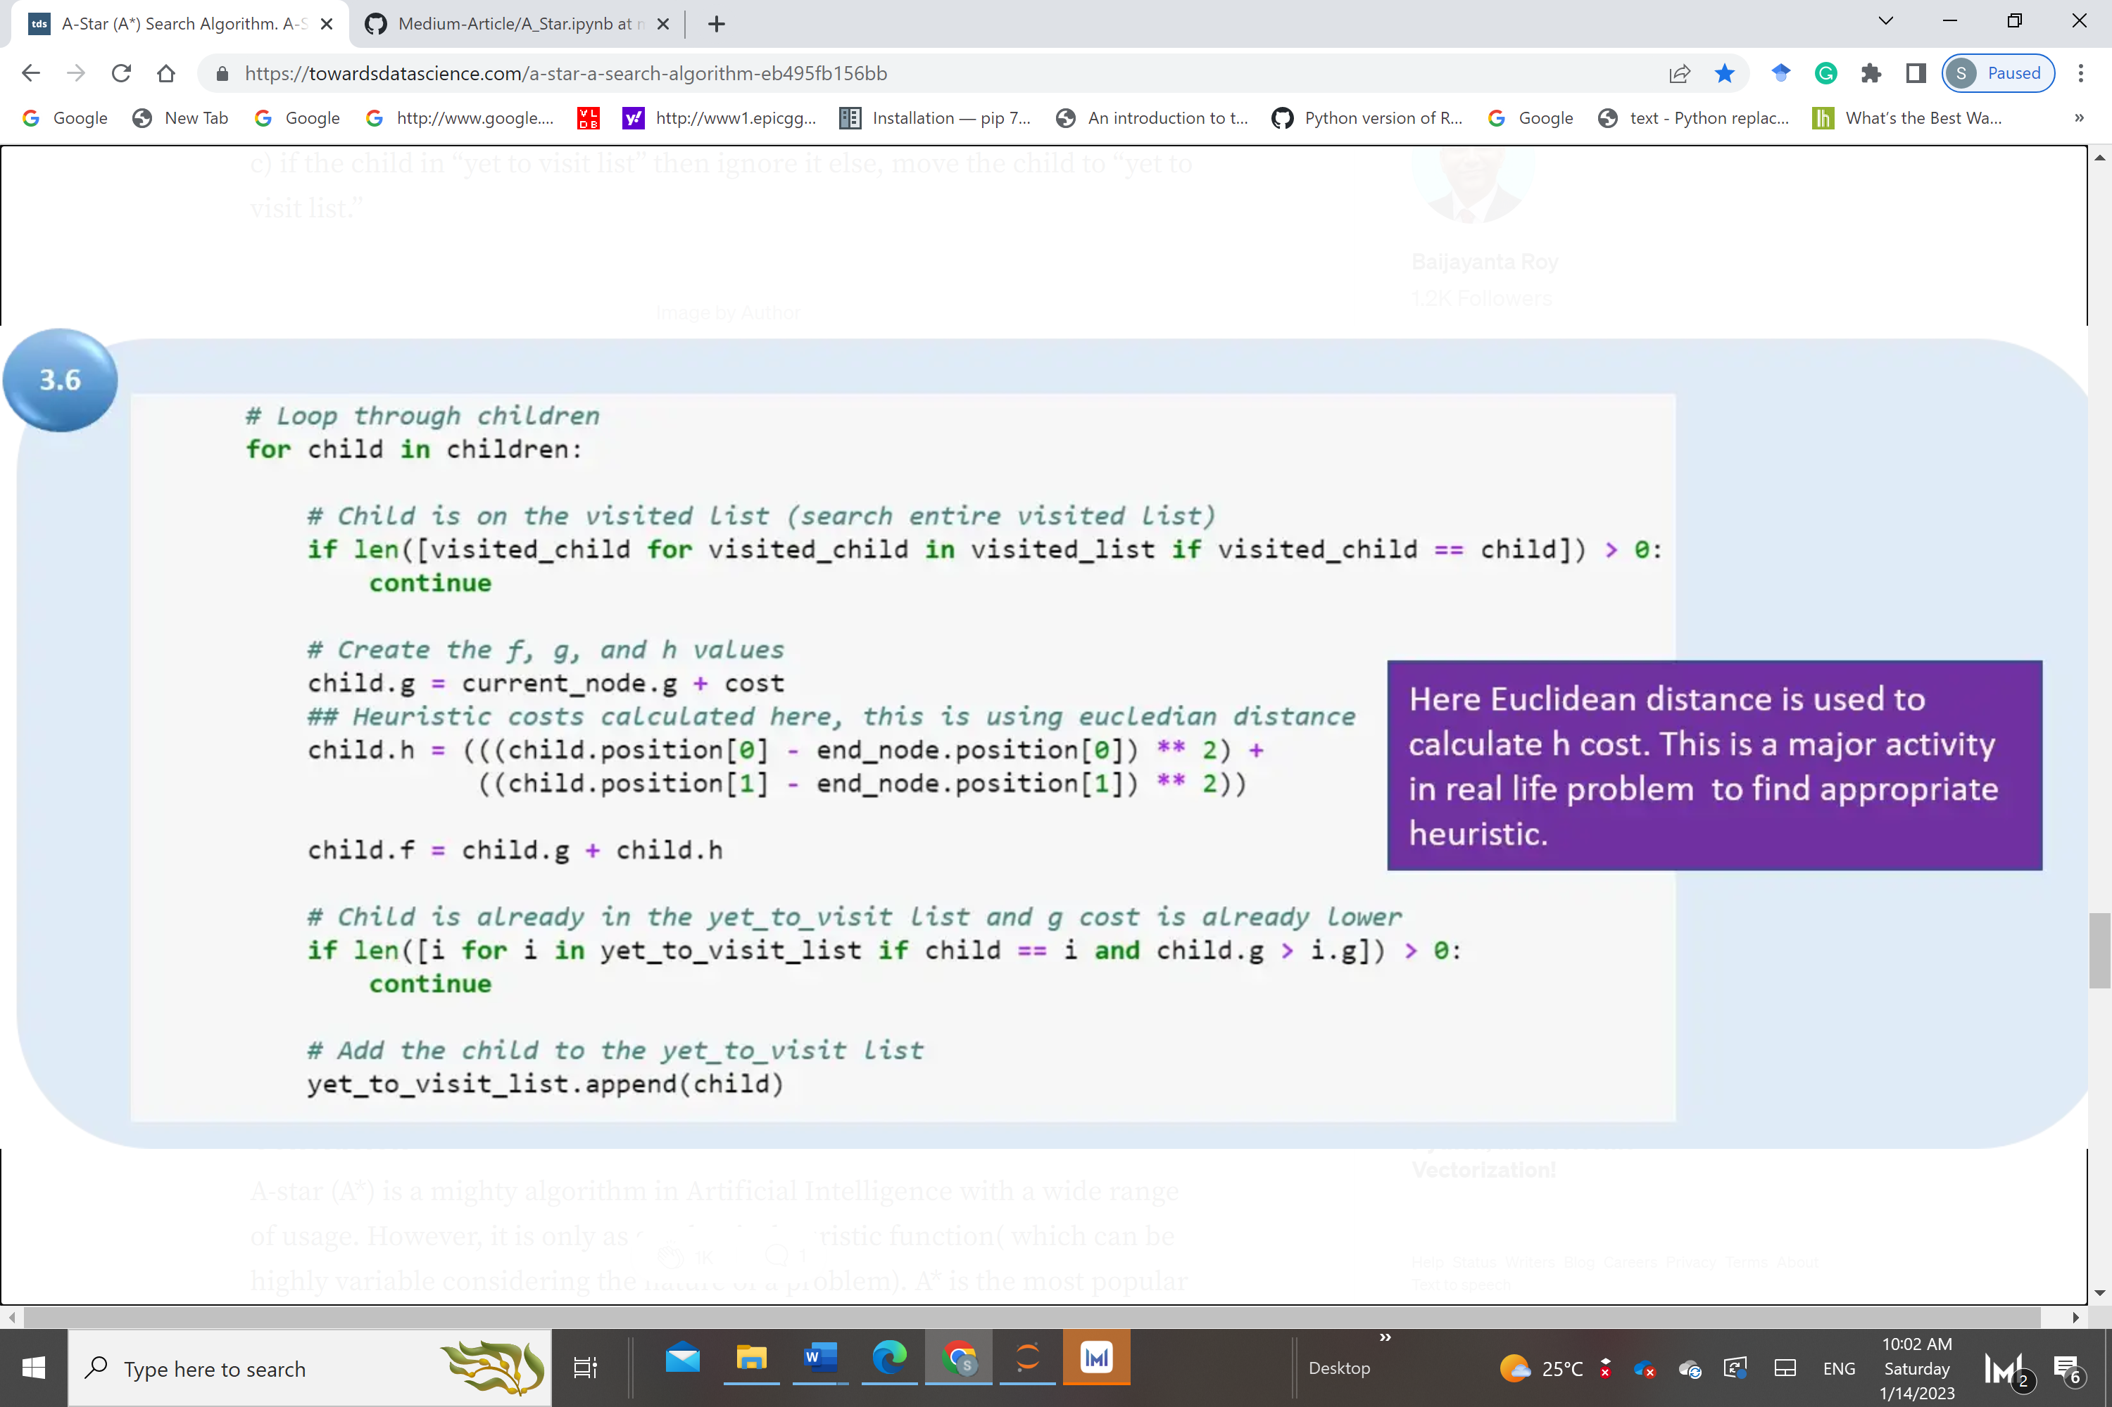

f

Now finally, we will run the program from the main with the maze and obtain the path. Refer to the path also shown using the arrow.

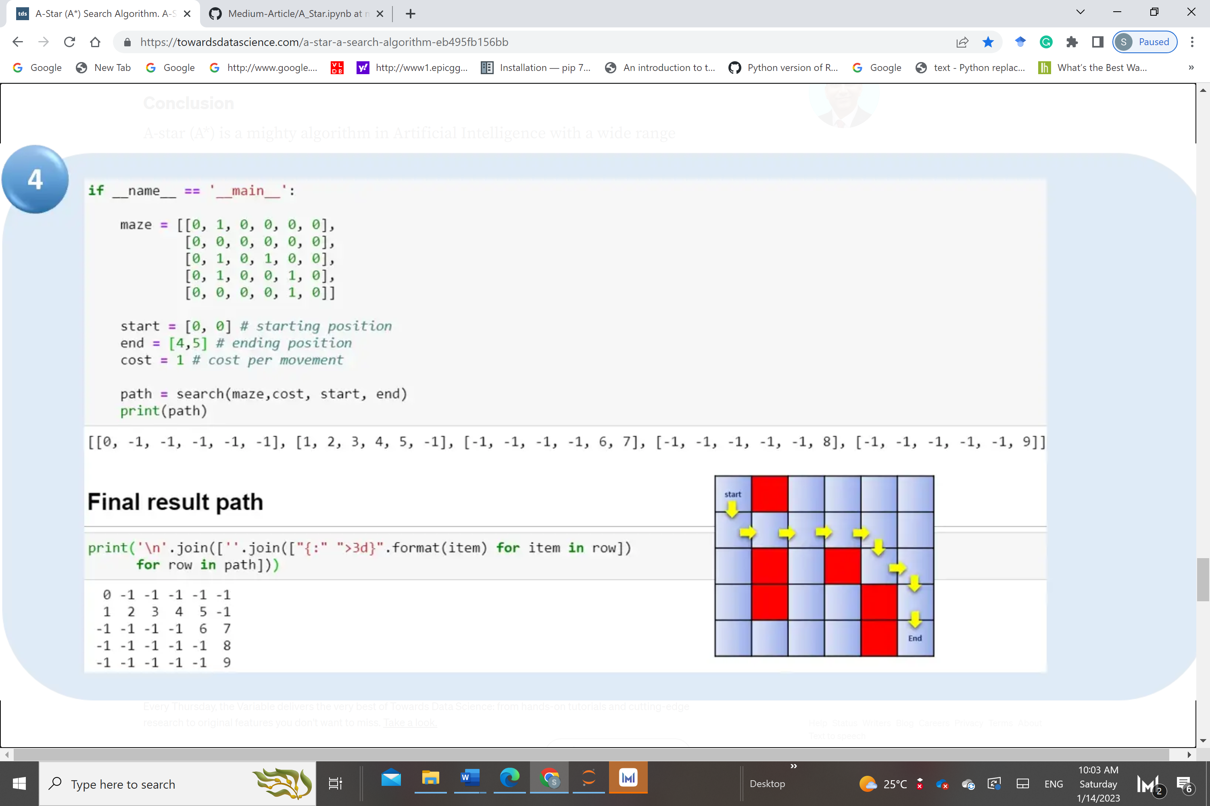

**Assessment:**

You are required to implement this lab and submit your work showing the code and results.

Optional: You may try to use a different distance measure as (Manhattan distance )